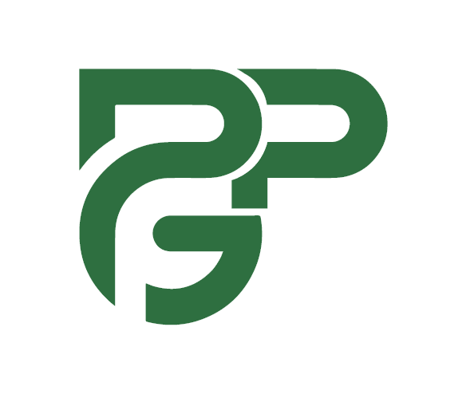  PROGRAM PERFORMANCE GROUP  Certified. Compliant. Results-Driven. | CAPABILITY STATEMENT  UEI: PKE9LRESRKD4  CAGE: 22P47  NAICS: 541612, 541613, 541614, 621610, 561110  Entity Est.: 2017

ABOUT PPG  Program Performance Group delivers measurable outcomes for complex, multi-stakeholder programs. Backed by PMP-certified leadership and hands-on experience managing compliance-heavy, Medicaid-funded service delivery, PPG brings rigorous program management discipline to every engagement, combining healthcare program expertise and organizational leadership capabilities to keep programs on scope, on schedule, and fully compliant.  CORE CAPABILITIES  - Program Management: end-to-end lifecycle oversight, milestone tracking, risk mitigation  - Project Management: scope, schedule, cost, and quality management for complex engagements  - Operational Consulting: process improvement, workflow optimization, compliance-driven operations  - Compliance & Documentation: Medicaid billing, CPARS-ready reporting, regulatory adherence  - Stakeholder Coordination: multi-agency, multi-stakeholder program delivery  - Workforce & Contractor Management: independent contractor oversight, scheduling, performance  - Healthcare Program Management: home healthcare and Medicaid-funded disability services oversight, including care coordination, discharge transition planning, insurance and benefits navigation, home modification contractor vetting, and multi-account service delivery  PAST PERFORMANCE  State of Ohio: DODD Service Delivery Program  Client: Ohio Department of Developmental Disabilities  Scope: Round-the-clock program management for multiple Medicaid clients  Role: Full accountability for service delivery, billing, compliance documentation, and multi-stakeholder coordination  Duration: 2021 – Present  Performance: Clean compliance record; uninterrupted service delivery maintained throughout engagement  Reference: Pamela Waite, Service Coordination, FCBDD | pamela.waite@fcbdd.org | (614) 342-5363 | DIFFERENTIATORS  - MBA in Organizational Leadership: Franklin University (2026)  - PMP-Certified Leadership: rigorous, standards-based program delivery backed by a credential recognized across industries  - Compliance-Driven, Audit-Ready Delivery: direct experience managing state-contracted, Medicaid-funded, compliance-heavy programs, including documentation, billing, and regulatory reporting  - Bilingual & Cross-Cultural Program Coordination: English & Somali; coordinated community outreach and business translation/interpretation services, managed multi-city logistics for a large-scale national event, and liaised across multiple government agencies on behalf of refugee families, helping them secure healthcare coverage, benefits, and public assistance needed to stabilize in their new communities  - Operational Consulting: process improvement, workflow optimization, and compliance-driven operations management tailored to organizational and regulatory requirements, including developing an AI-assisted billing tool that cut billing time in half, integrating AI into scheduling to simplify documentation across multiple concurrent client accounts, negotiating vendor contracts to reduce costs, and consolidating office roles to lower overhead while maintaining service quality  - 9-Year Legal Entity: established 2017, providing an operating and compliance history beyond a newly formed startup  CONTACT  Fatima Osman, PMP  Principal Consultant & Founder  (614) 324-9773  fatima@ppgroup.ai  www.ppgroup.ai  Worthington, OH

Program Performance Group | Your Mission. Our Expertise.

